1.Write the class Date having attributes like day, month & year. Add default & parameterized constructors. Add getters & setters. Add method to print the date. Add method to swap two dates.

package com.zensar;

public class Date
{
Date()
{
this.day="Monday";
this.month="January";
this.year="2022";
}
Date(String day,String month,String year)
{
this.day=day;
this.month=month;
this.year=year;
}
private String day;
private String month;
private String year;
public void setDay(String day)
{
this.day=day;
}
public void setmonth(String month)
{
this.month=month;
}
public void setyear(String year)
{
this.year=year;
}
public String getDay()
{
return day;
}
public String getMonth()
{
return month;
}
public String getyear()
{
return year;
}
public static void printDate()
{
Date d = new Date();
String day=d.getDay();
String month=d.getMonth();
String year=d.getyear();
System.out.println("stored date : " + day+ "/" + month+"/" + year);
}
public static void swapDate()
{
Date d = new Date();
String day=d.getDay();
String month=d.getMonth();
String year=d.getyear();
d.setDay("Friday");
String day2=d.getDay();
System.out.println(" before swapping = "+ day + " " + day2);

String temp;
temp=day;
day=day2;
day2=temp;
System.out.println(" after swapping ="+ day + " " + day2);

}
public static void main(String[] args) {
printDate();
swapDate();
}}

OUTPUT:

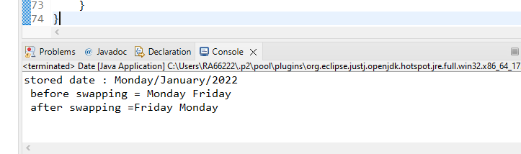

- Write a class ComplexNumber having attributes real & imaginary. Add functions like add, subtract, multiply & swap.

package com.zensar;

public class ComplexNumber
{
double real,img;
ComplexNumber()
{
}
ComplexNumber(double real,double img)
{
this.real=real;
this.img=img;
}
public String getValue()
{
return real+"+"+img+"i";
}
public static ComplexNumber swap( ComplexNumber c1, ComplexNumber c2)
{
ComplexNumber complexNumber = new ComplexNumber();
System.out.println("Before swaping-1 =" + c1.real + "+" + c1.img + "i");
complexNumber.real=c1.real;
c1.real=c1.img;
c1.img=complexNumber.real;
System.out.println("after swaping-1= " + c1.real + "+" + c1.img + "i");
complexNumber.real=c2.real;
c2.real=c2.img;
c2.img=complexNumber.real;
System.out.println("Before swaping-2 = " + c2.real + "+" + c2.img + "i");
System.out.println("after swaping-2= " + c2.real + "+" + c2.img + "i");
return complexNumber;
}
public static ComplexNumber add( ComplexNumber c1,ComplexNumber c2)
{
ComplexNumber complexNumber=new ComplexNumber();
complexNumber.real=c1.real+c2.real;
complexNumber.img=c1.img+c2.img;
return complexNumber;
}
public static ComplexNumber sub( ComplexNumber c1,ComplexNumber c2)
{
ComplexNumber complexNumber=new ComplexNumber();
complexNumber.real=c1.real-c2.real;
complexNumber.img=c1.img-c2.img;
return complexNumber;
}
public static ComplexNumber mul( ComplexNumber c1,ComplexNumber c2)
{
ComplexNumber complexNumber=new ComplexNumber();
complexNumber.real=c1.real*c2.real;
complexNumber.img=c1.img*c2.img;
return complexNumber;
}

public static void main(String[] args)
{
ComplexNumber a=new ComplexNumber(5,8);
ComplexNumber b=new ComplexNumber(7,9);
System.out.println(" Swapping ");
swap(a,b);
ComplexNumber c=add(a,b);
System.out.println("****Adding****");
System.out.println(c.getValue());
ComplexNumber c1=sub(a,b);
System.out.println("****Substraction****");
System.out.println(c1.getValue());
ComplexNumber c2=mul(a,b);
System.out.println("****Multiplication****");
System.out.println(c2.getValue());
}
}
OUTPUT:
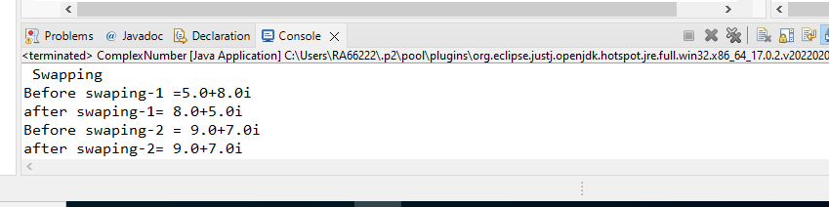

- Write a class Account & add methods like deposit, withdraw, print etc.
package com.zensar;

public class Account
{
private int accountNumber;
private double currentBal;
Account(){

}
Account(int accountNumber)
{
this.accountNumber=accountNumber;
}
public void setAccountNumber(int accountNumber)
{
this.accountNumber=accountNumber;
}
public int getAccountNumber()
{
return accountNumber;
}
public void setCurrentBal(double currentBal)
{
this.currentBal=currentBal;
}
public double getCurrentBal()
{
return currentBal;
}
public void deposit(double amount)
{
this.currentBal += amount;
System.out.println("Your account is credited with rs-" +amount+"your balance is rs-" + currentBal );

}
public void Withdraw(double amount)
{
if(currentBal>=amount)
{
this.currentBal-=amount;
System.out.println("your balance amount after dedecting rs-" + amount + "is rs-" +currentBal);
}
else
System.out.println("insufficient fund");

}

public static void main(String[] args) {
Account account = new Account();
account.setAccountNumber(543742);
System.out.println("Your account number is :" + account.getAccountNumber());
account.setCurrentBal(15000.0);
account.deposit(25000.0);
account.Withdraw(35000.0);

}
}
OUTPUT:
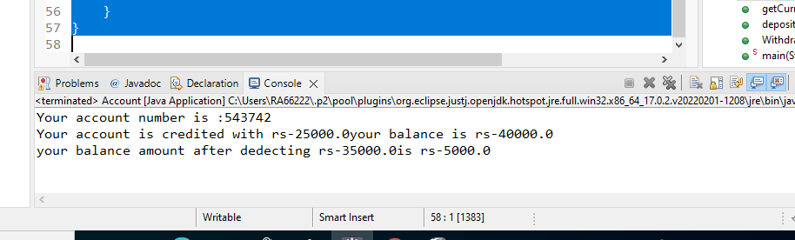

- Write a program to implement a Stack using arrays as follows-
class StackedArray {
int ary[];
push(--) { }
pop() {--) {}
}
package com.zensar;

public class Stack
{
int arry[]=new int[5];
int top=0;
public void push(int data)
{
arry[top]=data;
top++; }
public void pop()
{
int data;
top--;
arry[top]=0;
}
public void display()
{
System.out.println("array elements are : " );
for(int i=0;i<arry.length;i++)
{

System.out.println("arr[" + i +"] ="+arry[i]);
}
}
public static void main(String[] args)
{

Stack s = new Stack();
s.push(39);
s.push(42);
s.push(55);
s.push(64);
s.push(71);
s.display();
s.pop();
s.display();
}
}

}
OUTPUT:
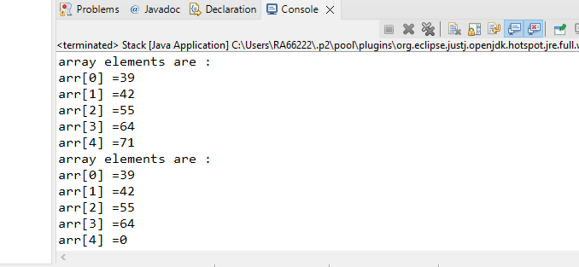

- Write a program to implement a Queue using arrays as follows-
class QueuedArray {
int ary[];
push(--) { }
pop() {--) {}
}
package com.zensar;

public class Queue
{
int n = 200;
int arr[] = new int[n];
int rear=-1, front = 0;

void enQueue(int value)
{
if(rear == (n-1))
System.out.println("queue is full");

arr[rear+1] = value;
rear++;
}

void deQueue()
{
if(rear == front)
System.out.println("queue is empty");

for(int i=0;i<=rear;i++)
arr[i] = arr[i+1];

--rear;

}

void display()
{
for(int i = 0; i<=rear ; i++)
{
System.out.println(arr[i]);
}
}

public static void main(String[] args) {
Queue s = new Queue();
s.enQueue(40);
s.enQueue(250);
s.enQueue(48);
s.enQueue(55);
s.enQueue(66);
s.display();

System.out.println("After deQueue");
s.deQueue();
s.display();
}
}
OUTPUT:
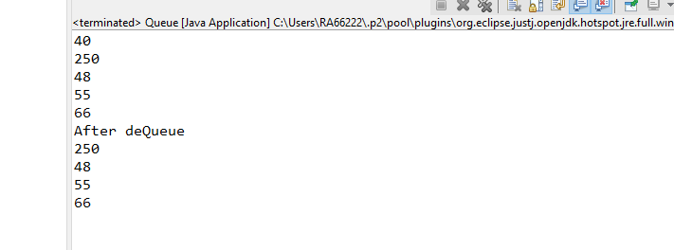

- Write a single tone class. Confirm that single tone class cannot be inherited.
package com.zensar;

public class Singletone
{
private static Singletone singletone=null;
public static Singletone singletoneMethod()
{
if(singletone == null)
{
System.out.println("object is null---create object");
singletone=new Singletone();
return singletone;
}
else
{
System.out.println("object cannot be created");
return singletone;
}

}
public static void main(String[] args) {
Singletone singletone=Singletone.singletoneMethod();
Singletone singletone1=Singletone.singletoneMethod();
}
}
OUTPUT:
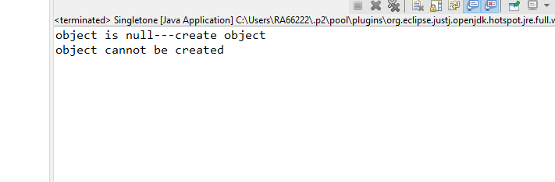

- Write java classes to build doubly linked list. Add functionalities like add new node, insert node, delete node, count nodes & print linked list.
class Node {
Node previous;
Node next;
Int data;
}
package com.zensar;

public class Doublylinkedlist
{
Node head,tail = null;
class Node
{
int data;
Node prev;
Node next;

Node(int d)
{
data = d;
}
}

void insert(int data)
{
Node new_node = new Node(data);

if(head==null)
{
head = tail = new_node;
head.prev = null;
tail.next = null;
}

tail.next = new_node;
new_node.prev = tail;
tail = new_node;
new_node.next = null;

}

void delete(Node del)
{
if(head == null )
{
return;
}

if(head == del) {
head = del.next;
}

if(del.next != null) {
del.next.prev = del.prev;
}

if(del.prev != null) {
del.prev.next = del.next;
}
return;
}
void printNodes()
{
Node curr = head;
if(head == null)
{
System.out.println("DLL is empty");
return;
}

while(curr!=null)
{
System.out.print(curr.data + "->" );

curr = curr.next;
}
System.out.println(" ");
}

public int countNodes() {
int counter = 0;

Node current = head;

while(current != null) {
counter++;
current = current.next;
}
return counter;
}

public static void main(String[] args) {
Doublylinkedlist dl = new Doublylinkedlist();

dl.insert(35);
dl.insert(38);
dl.insert(45);
dl.insert(55);

dl.printNodes();

dl.delete(dl.head.next);
dl.delete(dl.tail.prev);

System.out.println("after deletion");
dl.printNodes();

System.out.println("No. of nodes: "+ dl.countNodes());

}
}
OUTPUT:
